27.68: a) By examining a small piece of the wire (shown below) we find:

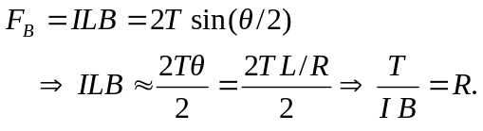

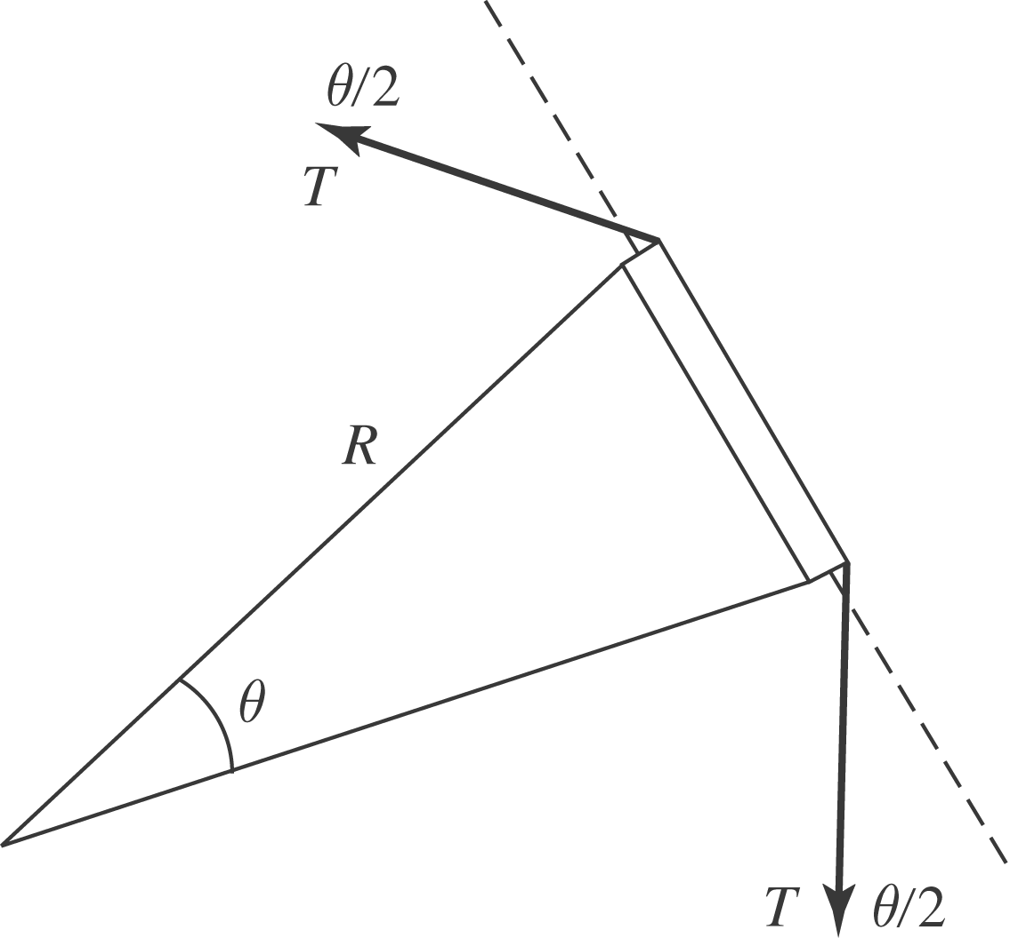

b) For a particle:
